[E115] Boil temperature sensor

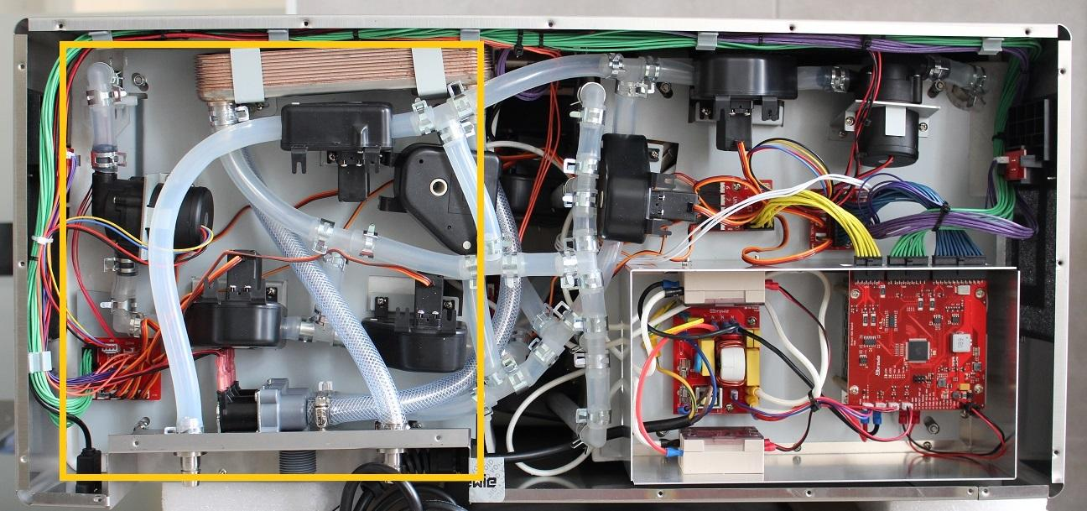

The boil temperature switch is located under the boil side service plate attached to the side of the boil tank.

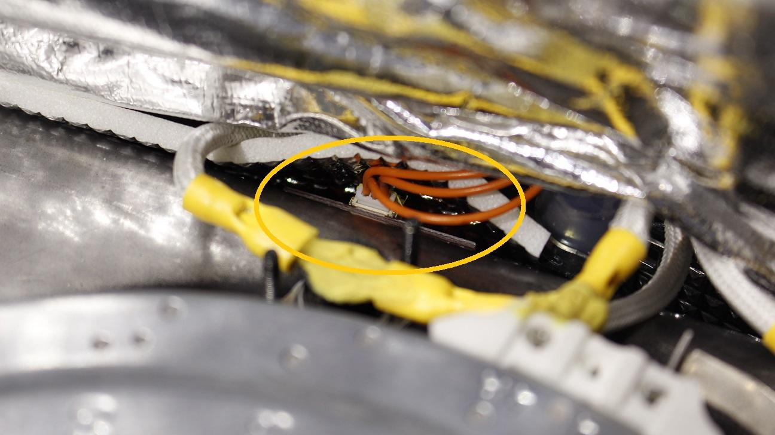

To reach the switch it is necessary to partially remove the boil service plate.

Move aside the USB port and the rear plate by unscrewing the indicated screws.

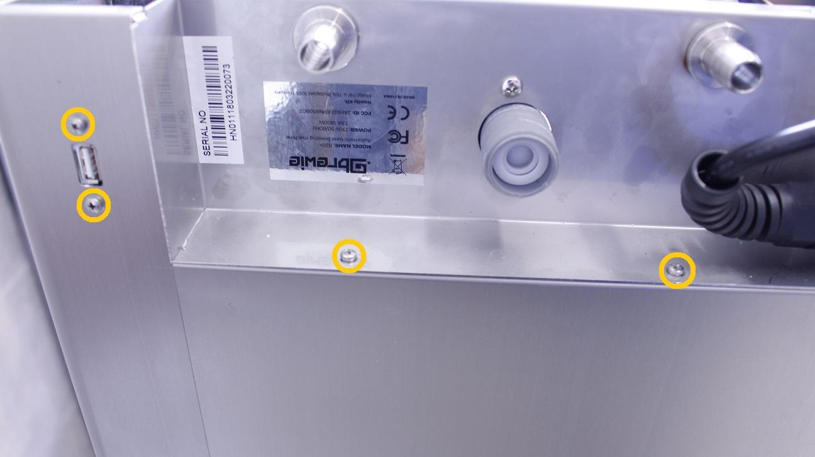

Unscrew two of the boil plate fastening locknuts.

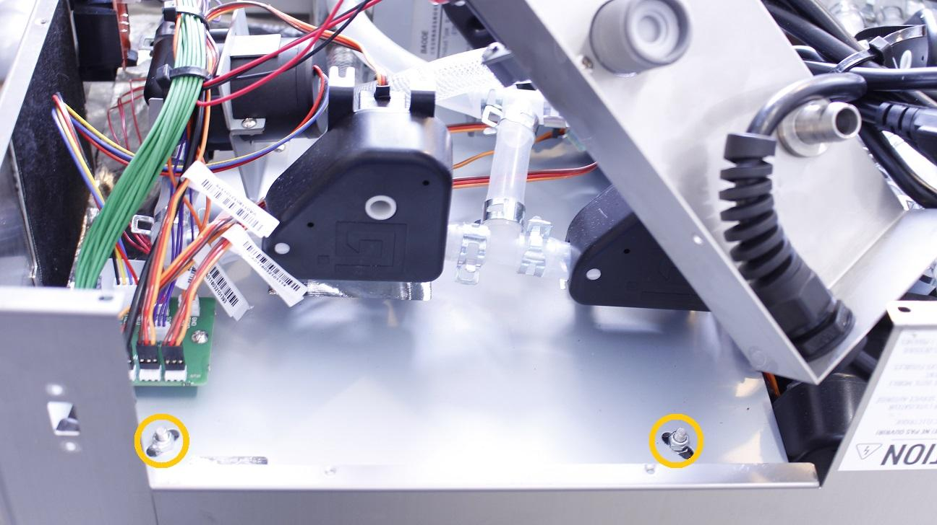

Disconnect the cable from the power button PCB.

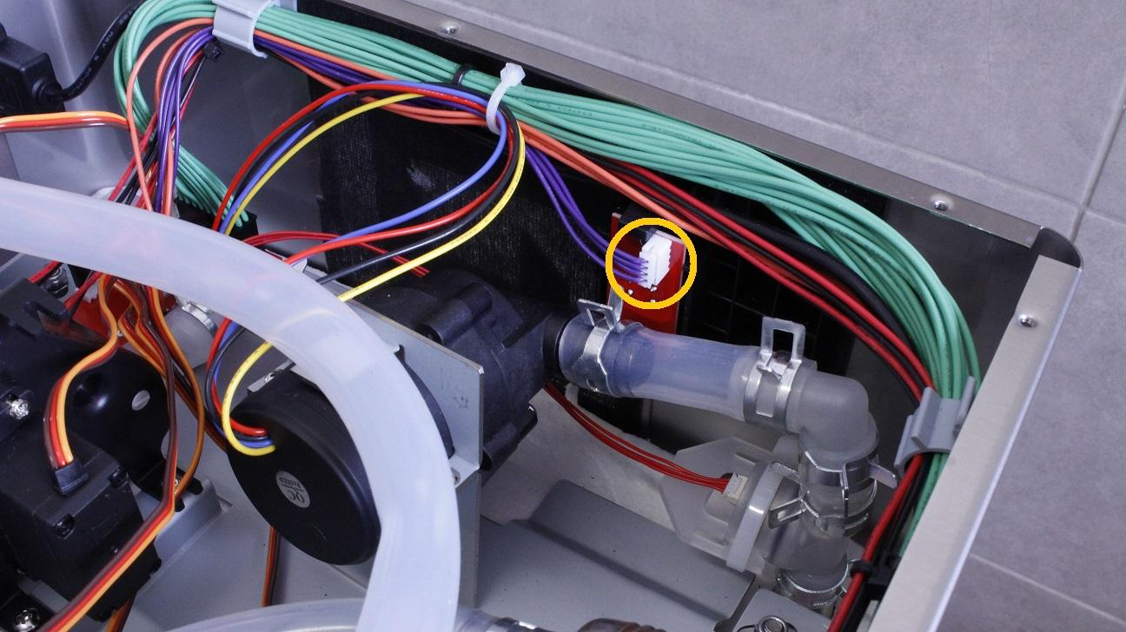

Remove the cable bundle from all of the holders.

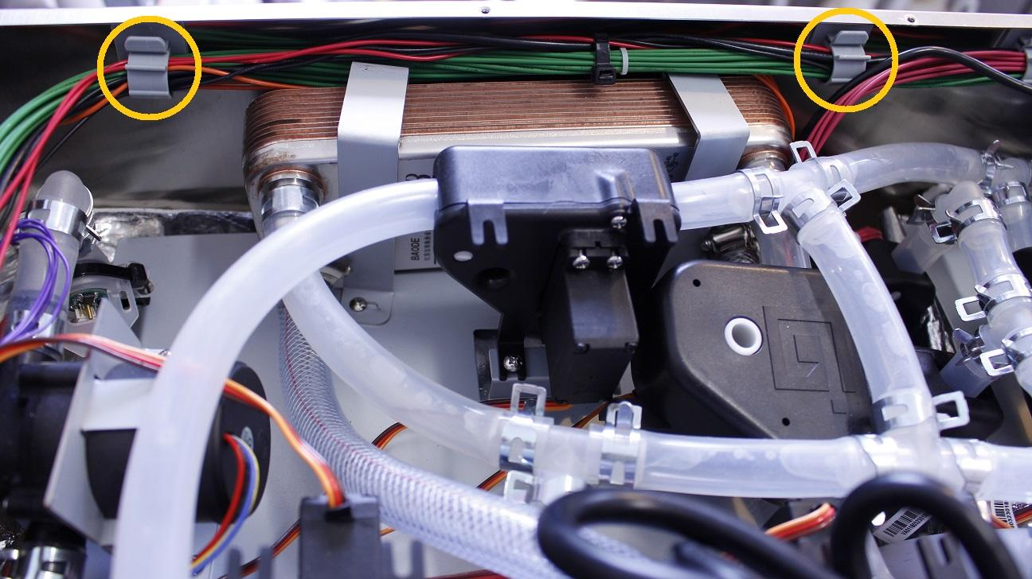

Disconnect the silicone tube from the outlet of the boil tank by pulling off the clamp right under the pressure meter.

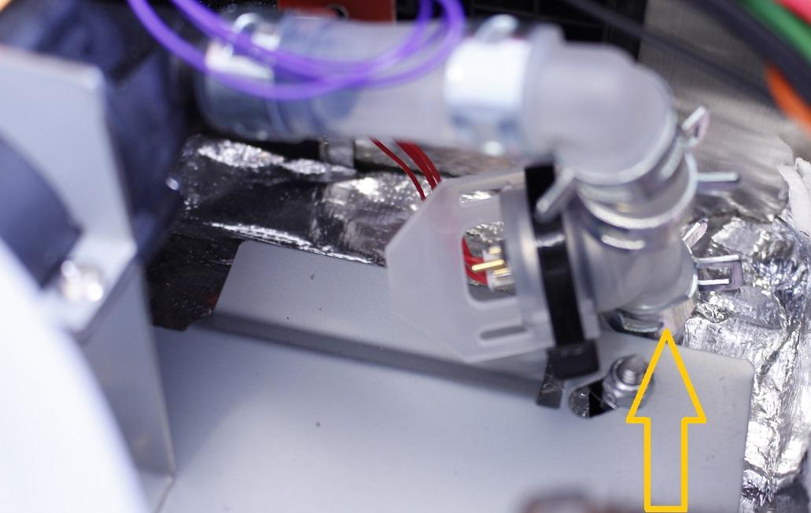

First the clamps of the heat exchanger have to be removed then the remaining two boil plate fastening locknuts.

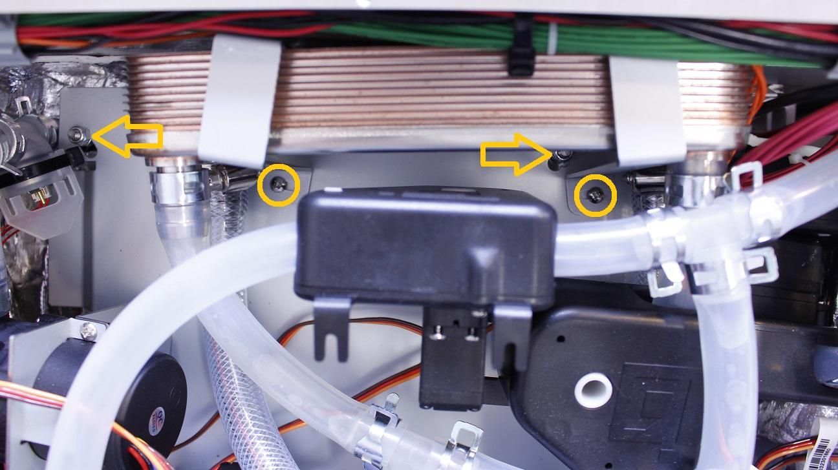

Open up the whole plate.

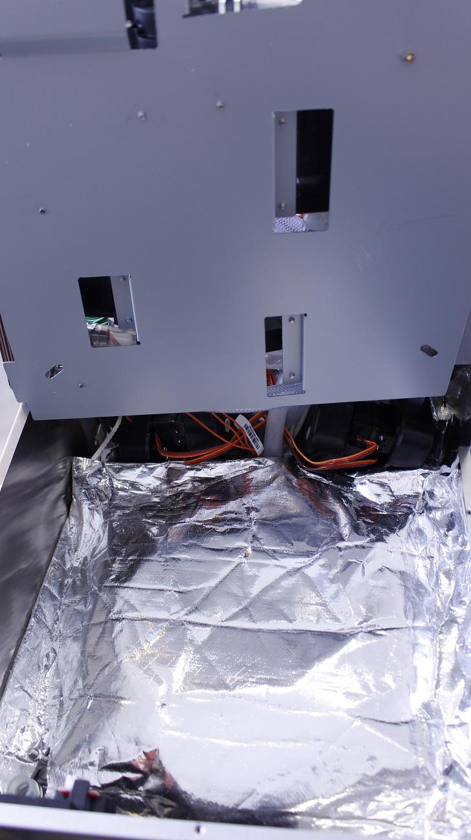

Carefully pull off the heat insulation from the threads and the outlet pipe.

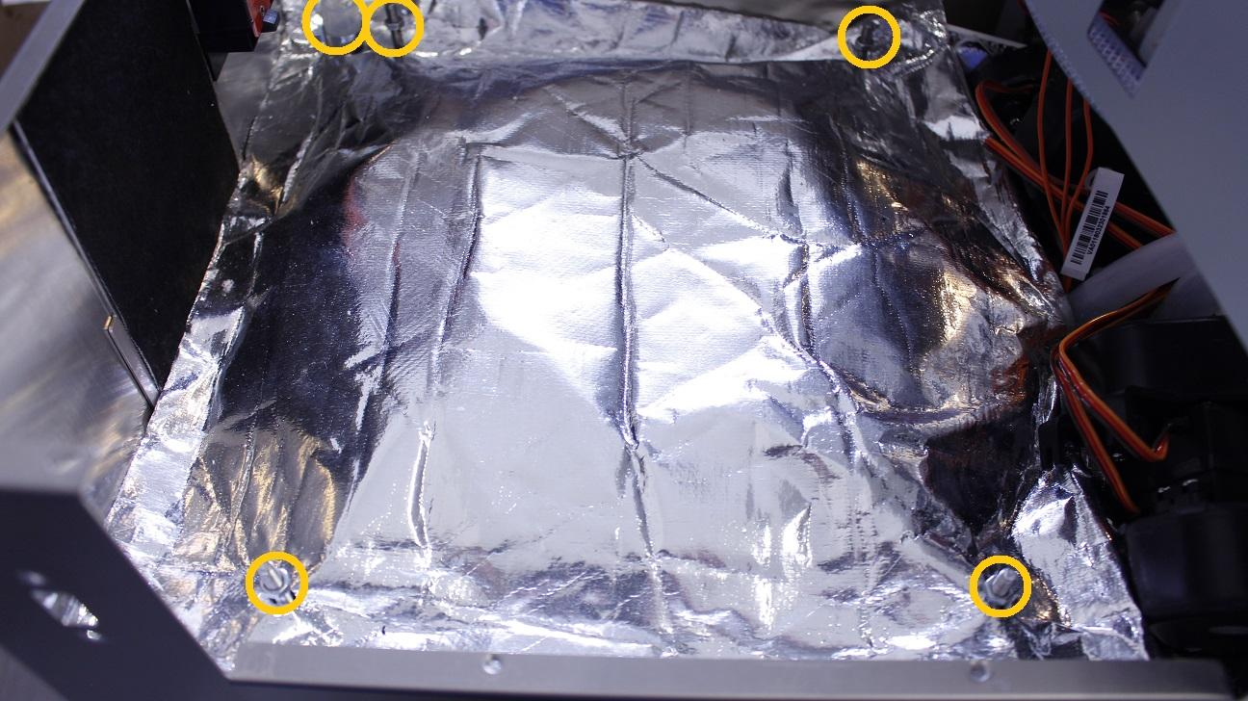

Simply turn the fastening clamps aside from the heater element and remove the isolation rubber.

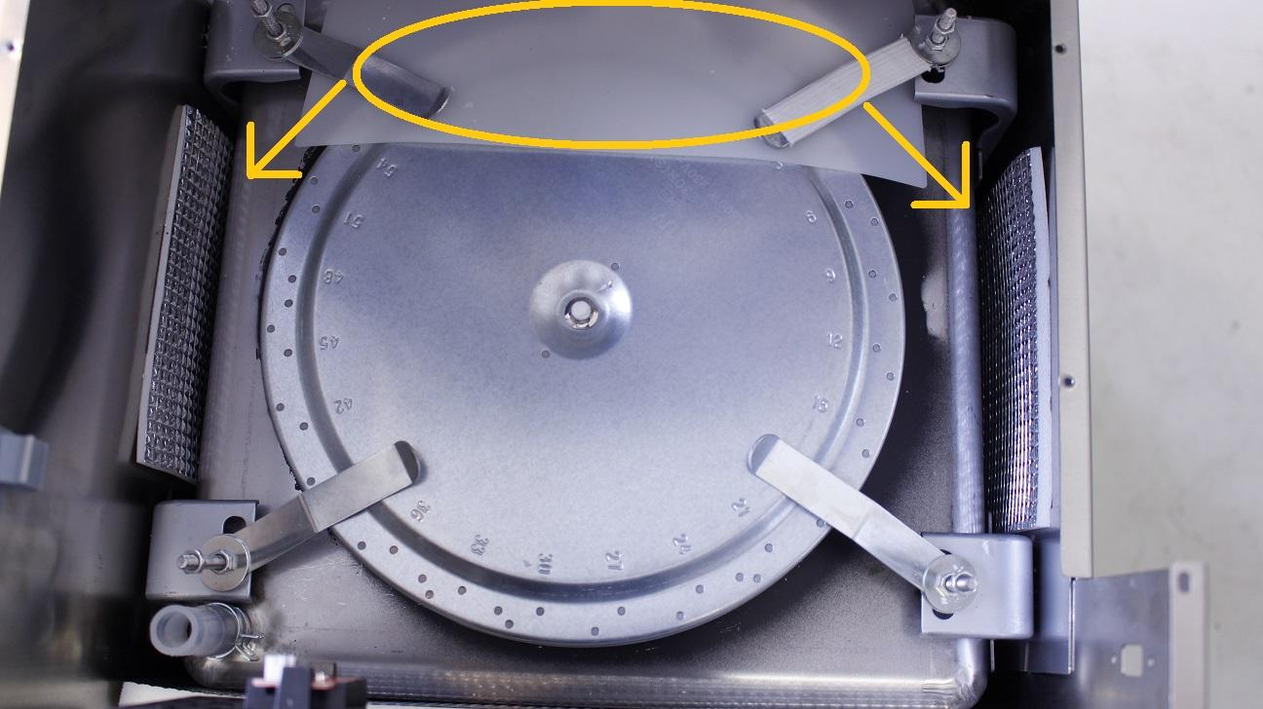

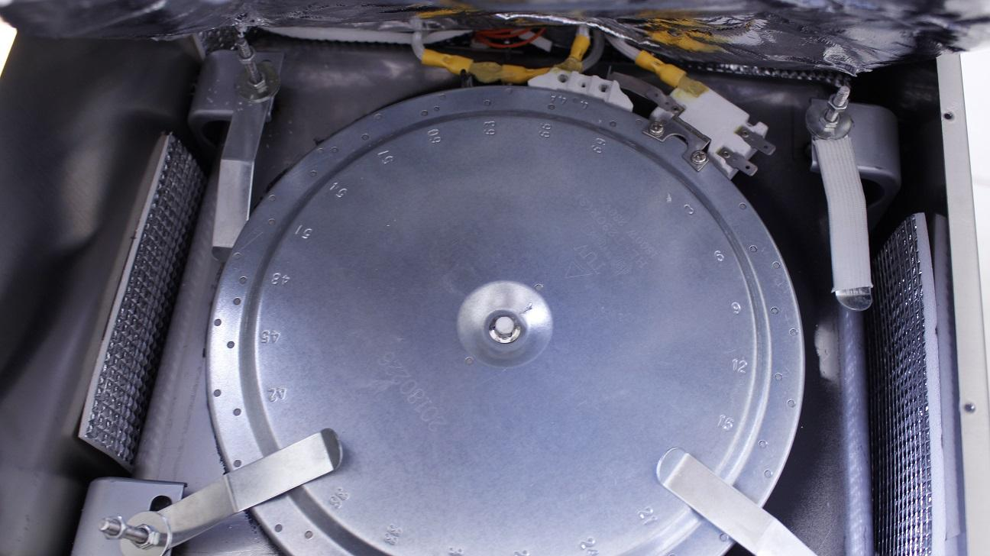

The temperature sensor can’t be replaced. A new one has to be glued to the side of the tank and the existing cable has to be connected to that. To avoid confusion, break the connector of the old sensor with a plier.



Reassemble consists of the same steps in reverse.